# Introduction

Digital hub is an office building in UCB, Birmingham. One of its rooms is currently being converted into additional lab space which will be used for teaching. As a contractor for the networking consultancy firm IT solutions, I have been tasked with implementing a network solution for the new lab space. Before that, this assignment will go over the basics of network security principles such as the CIA triad and how access control works. The next task goes over the plan for the network and how Cisco Packet Tracer will be used to create the new lab. Once a basic design is created, the implementation phase can begin. This is where the switches, routers, PCs, servers and firewall/networking technologies will be configured securely. Like any other project, there needs to be a testing phase after the implementation which will also provide user feedback to help better the network. Based on the results of the testing, a full evaluation of the security will be included.

# Task 1 – Conduct an Analysis of Network Security Principles

## Confidentiality

In networking, the principle of confidentiality means ‘Who needs to know what information’. Let’s say for example UCB’s new lab has online banking that is required for Wire transactions, it would be very irresponsible for them to share the details of the account to someone who didn’t work in the maintenance department. This would mean someone who would never need access to an account could obtain the details whenever they wanted.

This is the reason networks have methods of identification such as passwords. This is to verify that a user is who say they are and so they’re the only one who can access data that they’re responsible for. The password protects any data behind it so only someone who knows the password can access everything. Usually this isn’t enough, so Multi factor Authentication comes in. MFA adds an extra layer of verification to prove that the whoever enters the password is the one who truly owns the account. This can be in the form of a phone SMS or an email. After the password is entered, the phone or email registered is sent a passcode to further verify ownership. This is useful because it’s extremely easy to obtain a password from someone online or in real-life, so the MFA makes it harder for 3rd parties to access poorly secured data.

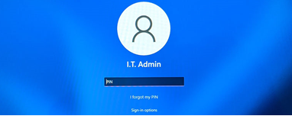

(Figure 1 microsoft.com, 2022)

## Integrity

For a network to have integrity, data stored needs to be accurate, consistent, secure, and complete. This can be anything from customer data to passwords and logins. Imagine the Digital Hub network had a data breach and information is now in the hands of an unauthorized user. The manager has requested for the passwords to be changed but this has not been updated in the system. This would cause a large amount of confusion within the company and the unauthorized user might still have access to their systems.

This is usually prevented by having someone do frequent system updates and checks. If the checks are performed routinely then the chances of inaccuracies within the data will decrease and the network would be a lot more secure.

## Availability

When we have secure data, we need to access it, “it needs to be available to us to be used at any time.” *(techtarget.com, 2023). The* problem with this is certain cyber threats can prevent information from being available. For example, if a student was a victim of a network attack, their private files such as medical records and address which may be used daily would no longer be available for them to access.

**Different Methods of Securing a network**

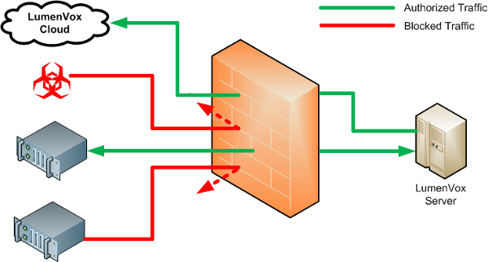It is especially important for UCB (University College Birmingham) to install a security system. Firewalls set a controlled barrier around your connection to the internet. Every inbound and outbound connection must be accounted for. This provides a good layer of security to prevent viruses from automatically sending information to and from your computer system over the internet. It works by letting the user select what ports they want to block traffic from so not every form of connection is blocked.

Figure 2: Network Firewall filtering traffic (free image from [lumenvox, 2022)](https://www.lumenvox.com/knowledgebase/index.php?/article/AA-02084/0/Firewall-Configuration.html)

## Antivirus

It’s crucial that UCB invests in a good Anti-Virus. They’re becoming more advanced to the point that they are embedded into most operating systems. They scan every directory, searching for any files that seem out of place. If a file is found, it alerts the user and gives them the option to “quarantine” and then delete the file. It is then placed in a folder where it cannot harm the system. Some examples of good antiviruses include Avast, Malwarebytes and Norton365.

Antiviruses would work well with UCB’s security department. This is because they have a built-in feature to perform checks every x number of days/weeks/months. The drawback is that viruses are becoming more advanced. Newer attacks will rename themselves to something inconspicuous which the antivirus may not pick up.

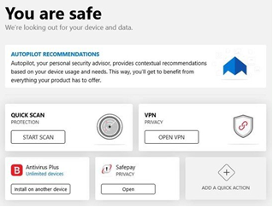

(Figure 3, antivirus, windowscentral, 2022)

## Setting up access control

Access control is the principle of making sure that employees have as little permissions as possible. Giving someone more permissions than needed means “they can always have sensitive information to misuse at any time.”*(ITgovernance, 2022).* This is epically worse where the info is more important *such as student details on the UCB database.* A manager would never give a cleaner the password to the computer system because it is not required to do the job.

# Task 2 - Design and implement a network prototype using a network simulator

For his section I have chosen to use Cisco Packet Tracer. It is software that allows users to "create network topologies and imitate modern computer networks." *(Wikipedia, 2023)*. useful for anyone since you can learn about the components required for a network. It also features lots of devices and protocols to create in-depth simulations, allowing for good troubleshooting in any scenario.

## Basic Example of Network

This is how the current network looks. It consists of 4 computers which are assigned to default IP addresses, a switch, router and an FTP server with username and password restrictions. The problem is it's small and lacks major security features.

Ci

## Detailed Network Design

Firewall – As mentioned earlier, a firewall’s job is to filter the incoming/outgoing traffic on a network based on the user defined policies. For this network, the firewall has been configured to block “Pings” from the PCs which denies them from communicating with each other. The other image shows the ping blocking working live.

Switches – A switches job is to allow devices on a network to communicate with each other, they are used “as a median for all the different types of devices to work on the network” *(cloudfare, 2023)* so they are very important to implement. In this image, the switch has been configured with a password to increase security. Another security feature added was the ping blocking so users cannot ping the IP addresses of the machine

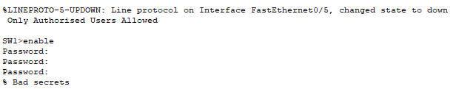

Routers – As the name implies, the role of the router in a network is to ‘route’ traffic and forward packets of data to the correct IP addresses. It’s essential that a router is configured properly and securely. When a router is left unsecured, “it is vulnerable to 3rd parties listening in to the data being sent.” *(cloudfare, 2023).* This simple network has been assigned a username and password. This is to prevent unauthorized users from gaining access to the network. The switch diverts the traffic to the router and sends the information to the server.

Device Configuration - the network wouldn’t serve any purpose without the devices. There would be any data to send across to the router/server. Since this is for a network lab, the computer systems will each be assigned an IP address and a Subnet mask. Each system in the network follows the same IP assignment ruling. 192.168.1.X, this also goes for the default subnet mask of 255.255.255.255

Subnetting – Subnetting allows for less network congestion by splitting up a single IP address into smaller subnetworks. This is achieved by a subnet mask. The default value is usually 255.255.255.0. This example in packet tracer shows the 2 different networks being connected by a DCE cable.

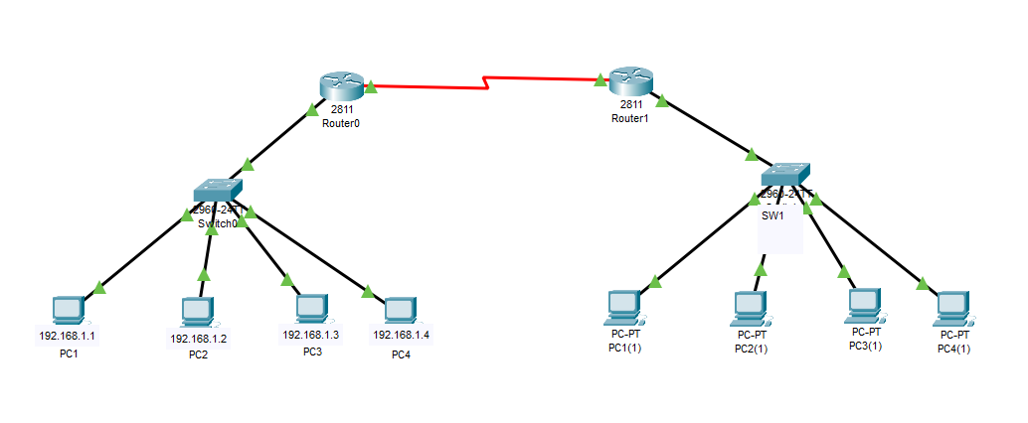

FTP Server – The FTP or File transfer protocol is “the method that computer systems use to specifically download and upload files on the internet.” *(Wikipedia, 2023).* For this feature to be available, there needs to be a server capable of using FTP. The server in the system has been set up to use FTP for the user login that was also added. It is important to set a username and password for the server too because it prevents 3rd parties from accessing the server and downloading malicious files. It also prevents unauthorized users from accidentally downloading these types of files.

HTTP/S – when accessing sites on the server, the protocol used will be the Hyper Text Transfer Protocol. This is different from FTP as “it is specifically for accessing sites and not downloading files. It’s also responsible for loading webpages using hyperlinks.” *(Wikipedia, 2019).*  Most websites usually use HTTPS which is “an extension of the standard protocol. The S stands for Secure” *(Wikipedia, 2018)* as it uses encryption technology called Secure Socket Layer or SSL. This is verified by the green lock logo next to the link of the site. The FTP server also has HTTP and HTTPS enabled for the secure login that was configured.

(figure 4, SSL certificate on YouTube, YouTube, 2024)

IPsec - IPsec (Inter-Domain Policy Security) is a set of techniques admins can use to enhance authentication, integrity, and confidentiality for data communication over IP network. Its benefits include being able to encrypt data such as Student’s Confidential information and allowing for secure remote access. This means UCB would be able to let students and staff securely connect to the network and complete work from home. On the downside, the cost of implementation can be expensive, especially for large universities. With many devices and students who need to connect to the network.

# Task 3 – Creating a test plan for the network

It’s always important to test a network to make sure connections are running smoothly. When working for a client it would be unprofessional to assume a network has no issues and then be presented with errors at the final stage. For this network, the test will include:

Physical Test to ensure cables are functioning

­Live test to make sure all components are communicating

The green lights on each of the components show that the physical connections are in working order.

IP config check for server

Ping test using the command prompt to make sure PCs are sending and receiving properly

Ping testing machines in Cisco Packet Tracer are useful for several reasons.

Verifying connectivity: The ping command can be used to determine whether two devices on the network can interact with one another. This can aid in troubleshooting connectivity issues.

Ping tests can also be used to calculate the round-trip time (RTT) that packets take to transit between two devices. High RTT values could be a sign of packet loss, network congestion, or other problems that could harm the performance of the network.

## Live test

# User Feedback

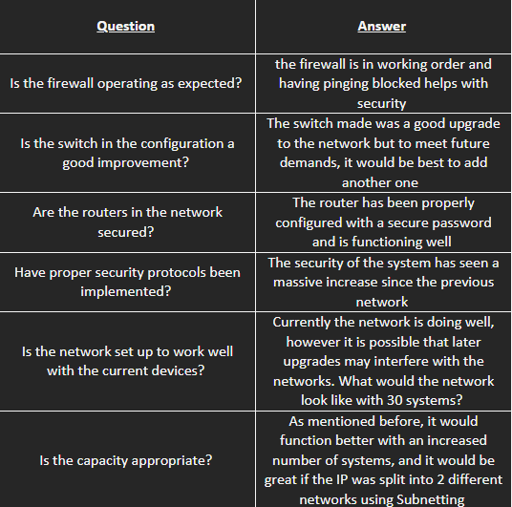

## Improvements

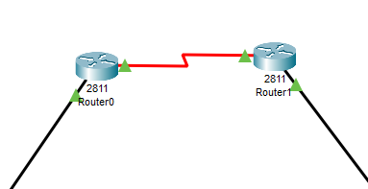

First, the client suggested that the server be Sub netted to ‘bridge’ the newly separated networks. So now the 2 routers can communicate with each other.

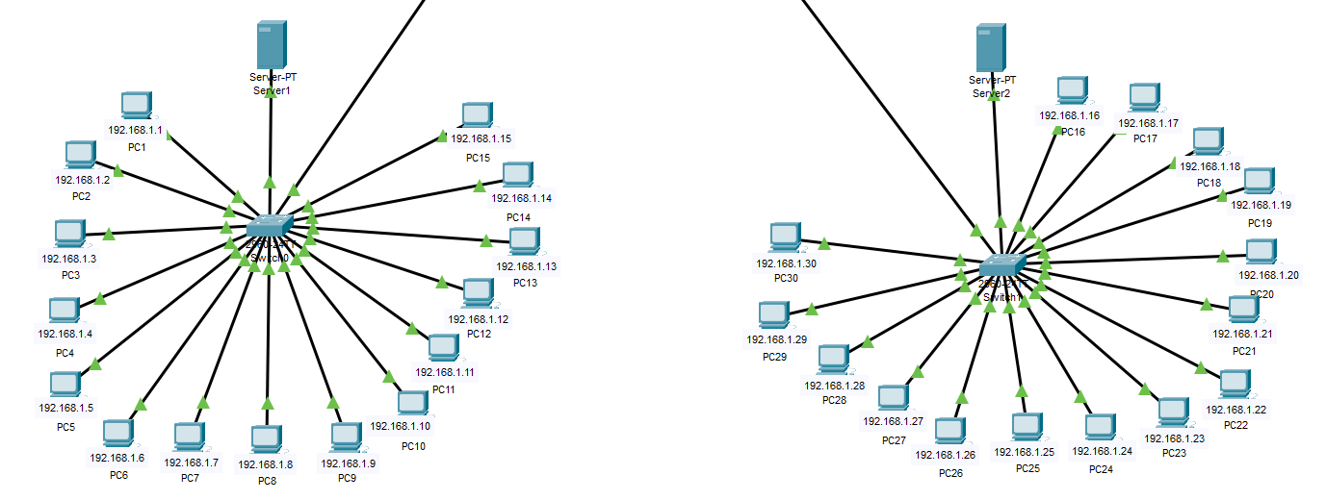The network has also been expanded to 30 systems. This change makes sense due to UCB being a university. Larger classes would be able to take advantage of the network without suffering from dips in network speed and performance.

These changes also facilitate the growth of UCB’s online courses. More students could enroll per course since there’d be more computing power.

# Quality of Service

Quality of Service or QoS is a set of principles that are used “to manage the traffic of a network and make sure that the most important apps receive the highest priority.” *(Fortinet, 2022).* In places where there are multiple users on a network (like UCB’s network), QoS can help keep performance consistent. QoS is made up of these core techniques:

Prioritization – As mentioned above, QoS can help distribute resources to the most demanding applications and traffic. For example, voice traffic can be prioritized over video traffic, and video traffic can be prioritized over web browsing traffic. In this specific scenario, UCB’s systems would most likely need web traffic to be at higher priority. QoS would then provide lower latency and increased bandwidth to web applications over voice and video to boost performance when users are browsing the internet.

Traffic Shaping – Too much traffic on any network will always cause lag and disruption. Traffic shaping’s job is “to help streamline any congestion that may occur.” *(barracuda, 2023).* When users download large files or stream videos, data ‘bursts’ are created on the network. These bursts negatively impact network performance, so traffic shaping helps maintain them by lowering download speeds. In UCB, this would be beneficial. Imagine all the users in a computing class were downloading an update for an app. All the PCs on the network would suffer major congestion so setting a cap on the speed would help keep the traffic at a steady pace.

Jitter Reduction - Jitter is “the variation in the time it takes for packets to arrive at their destination.” *(IR, 2022).* By using QoS, admins can mitigate jitter and smoothen out the connection. For UCB, this works hand in hand with traffic shaping. If the traffic is overflowing and many people are sending lots of packets at a single time, the network will have lots of Jitter so by shaping the traffic well, there would also be a decrease in network jitter.

Error control – QoS can be used to handle errors in data transmission, reducing the chances of packet loss and keeping data integrity. This is crucial for applications that require reliable data delivery, such as file transfers. This is something UCB should implement on their network. If users are completing an exam where they need to use an online application, data transmission errors can result in a loss of work for students or file corruption when transferring data online.

# Evaluation

Overall, the system that was designed fits UCB's requirements and can be used to further benefit them. There are some areas in development that can help achieve this goal faster and ensure the network is error free if this project were to be repeated.

Design – UCB mentioned that the network is now appropriate for the number of students that will access the systems, however it wasn’t suitable at the start. Next time a project is done like this, it's essential to look at the scenario and implement the correct number of systems. For Example, if this was for a small office, it would make sense to have only 15 systems. However, if this was for a big industry, the number of PCs should be increased. Another benefit of the design is the security features implemented onto the devices. Lots of companies fail to take network security into account when making upgrades. UCB’s routers and switches are properly configured to block access to unauthorized users.

Planning – in terms of planning for a future project, it's important to have frequent meetings with the client. This makes sure the network is properly tailored to their needs and keeps progress documented making it easier for them to follow along with the project Aswell.

Configuration and Testing - The configuration of the system went well; the PCs were properly assigned IP addresses and network devices like the switches and routers were given security features. For the testing section, it would be better to implement a physical test of a network before completing the project, even if it works fully online, it's better to test the network in the actual location to prevent physical factors from affecting performance.

*End of Assignment*

*References*

Barracuda. “Traffic Shaping.” *Barracuda Networks*, [www.barracuda.com/support/glossary/traffic-shaping#:~:text=Traffic%20shaping%20(also%20known%20as](#:~:text=Traffic%20shaping%20(also%20known%20as).

Cloudflare. “What Is a Network Switch? | Switch vs. Router | Cloudflare UK.” *Cloudflare*, 2023, www.cloudflare.com/en-gb/learning/network-layer/what-is-a-network-switch/.

---. “What Is a Network Switch? | Switch vs. Router | Cloudflare UK.” *Cloudflare*, 2023, www.cloudflare.com/en-gb/learning/network-layer/what-is-a-network-switch/.

“Firewall Configuration | LumenVox Knowledgebase.” *Www.lumenvox.com*, www.lumenvox.com/knowledgebase/index.php?/article/AA-02084/0/Firewall-Configuration.html. Accessed 14 Jan. 2024.

Gillis, Alexander. “What Is Data Availability? Definition from SearchStorage.” *SearchStorage*, www.techtarget.com/searchstorage/definition/data-availability.

“How to Login to Windows 11 with a Local Account? - Microsoft Q&A.” *Learn.microsoft.com*, 15 Dec. 2021, learn.microsoft.com/en-us/answers/questions/663885/how-to-login-to-windows-11-with-a-local-account.

Irwin, Luke. “What Is Access Control?” *IT Governance UK Blog*, 16 Nov. 2022, www.itgovernance.co.uk/blog/what-is-access-control.

Media, I. R. “Network Jitter - Common Causes and Best Solutions | IR.” *Www.ir.com*, 2022, www.ir.com/guides/what-is-network-jitter.

updated, Nikki Johnston last. “Best Antivirus Software 2024.” *Windows Central*, 16 Mar. 2023, www.windowscentral.com/software-apps/best-antivirus-software#:~:text=Antivirus%20and%20data%20sharing&text=Your%20Windows%20PC%20comes%20with. Accessed 14 Jan. 2024.

“What Is Quality of Service (QoS) in Networking?” *Fortinet*, 2022, www.fortinet.com/uk/resources/cyberglossary/qos-quality-of-service.

Wikipedia Contributors. “File Transfer Protocol.” *Wikipedia*, Wikimedia Foundation, 20 Aug. 2019, en.wikipedia.org/wiki/File_Transfer_Protocol.

---. “HTTPS.” *Wikipedia*, Wikimedia Foundation, 8 Dec. 2018, en.wikipedia.org/wiki/HTTPS.

---. “Hypertext Transfer Protocol.” *Wikipedia*, Wikimedia Foundation, 20 Sept. 2019, en.wikipedia.org/wiki/Http.

---. “Packet Tracer.” *Wikipedia*, Wikimedia Foundation, 3 Sept. 2019, en.wikipedia.org/wiki/Packet_Tracer.

YouTube. “YouTube.” *YouTube*, 2023, www.youtube.com/.